Town of Wareham
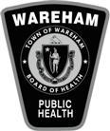
Board of Health
508-291-3100 x3197

Complaint Form

Please return all complaint forms to 54 Marion Rd, Wareham MA, 02571, Attention Wareham Board of Heath or email them to Health@Wareham.ma.us

Date: Time:

Property Address:

Property Owner:

Complainant
Address:

Phone:

Complaint:

